Software Engineering Digital Assignment

# Team Members:

16BCE0789 OM ASHISH MISHRA

16BCE0880 RAHUL TRIVEDI

16BCE0895 ISHAN TRIPATHI

16BCE0921 HIMANSHU DHAKA

16BCE0965 S DHANYA ABHIRAMI

## Online Grievance Rederssal System

# Introduction

Grievance Redressal System is a mechanism to receive and act on complaints and grievances reported by customers of a private organization or public citizens accessing a government (G2C) service. Grievance Redressal may be handled directly by organizations through their own websites or through call centers. A new innovation is smart web portals for grievance processing, connecting customers and action-takers directly through ICT media such as SMS and email.

# Stakeholders

In our assignment, Online grievance rederssal system, we have 5 stakeholders –

**Citizen:** They will write a complain for any issue they faced to municipal and NGOs.

**Municipal:** They will look into the complain and will pass the details and steps to the Manager of particular Department.

**NGOs:** They will do the same thing as Municipal but they will have different problems to check like malnutrition, orphans, diseased people who need help as financial support not present etc. They will also pass the things to manager.

**Manager:** They will look into the report and assign employees to go and check the condition

**Employee:** They will follow the instructions of the manager like going to the site for inception, contact the complainer, check other related documents etc.

# Description of How the things are taking place.

First all the 5 types of the stake holders make Authentication under the online grievance rederssal system.

Authorities Details(Registration Form): UserType(Citizen, Municipal, NGOs, Manager, Employee), FullName, Gender, DataOfBirth, Address, PhoneNumber, Email, Username, Password, Re-EnteredPassword.

LogIn: Username, Password

If the Citizen type is chosen, the person can go for Complain Issuing with these details:- UserId, Name, To(whom to send), Subject, Description.

If the Citizen sends the Complain the following things will be generated on the Citizen’s View complain: UserID(ID of the user who sent the report), ReportID(unique ID of the report), Status(waiting or processing).

The other stakeholders will view it as:-

View Complain: UserID(who has sent), To(who has received), Subject, Description, ReportID, Timing, Status,Change_Status.

The report is sent to municipal or NGOs who review and send it to the Manger of particular department. The Mangers see the things and assign it to the employer to see into the report by doing the instructions given to them.

# ER Diagram

Attributes for Citizen, Employee, Manager, Municipal and NGOs in common, thus mentioned separately:

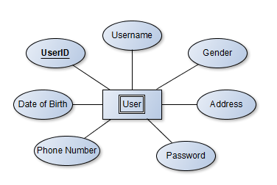

## The Whole ER Diagram:-

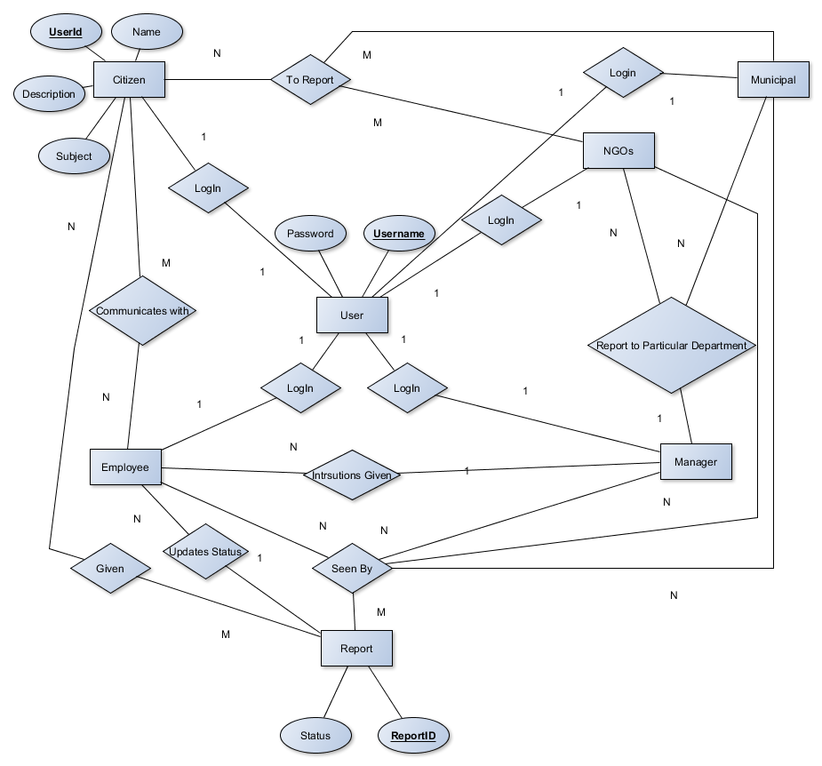

Thus we can see how they are interlinked. The citizen complains which can be viewed by others. The NGO and Municipal gets the complain from the Citizen and report it to particular department. The Department Manger looks through the Report and gives instruction to the Employee. The Employee follows the instruction, communicates with the citizen and updates the report given by the Citizen.

# Class Diagram:

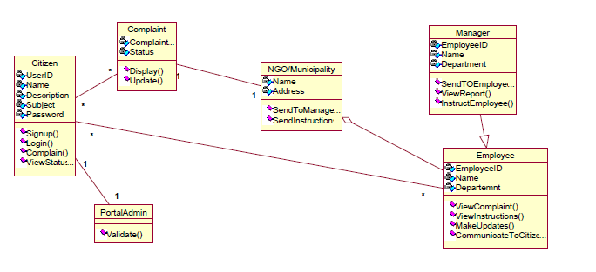

Thus we see after LogIn the Citizen Complains which goes to the NGOs or Municipal according to the complain given. The particular Department Manager after getting the report sees the things needed and informs to Employee to take all actions to be taken. The Employee(s) in turn does the things assigned and updates the report. The Employee has to communicate with the Citizen and visit the site for inquiry.

# Activity Diagram:

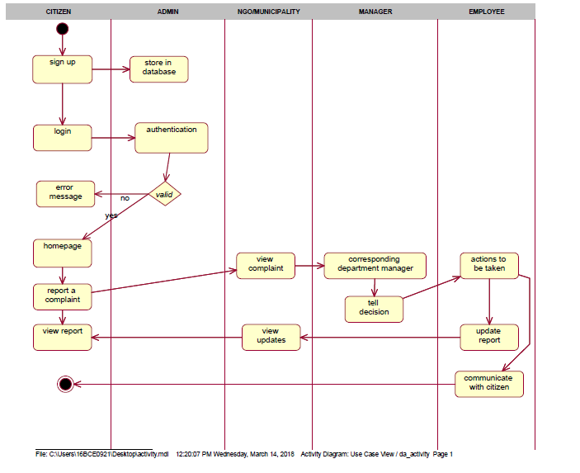

The Activity Diagram shows the flow of control. The user here is the citizen who logs in and checks for authentication. If the validation is wrong error message is shown else home page is shown. Then the user gives the complain to the NGO or Municipal who sends it to the particular department manager. The Manager gives instruction to the Employee. The Employee takes the actions given to him/her. The employee communicates with the citizen and updates the report for any progress in the issues.

# Conclusion:

This is the combined work of our team.

We have made the specific diagrams :-

1. Class Diagram
2. ER-Diagram
3. Activity Diagram

While completing this Digital Assingment we understood the working of grievance rederssal system. It was a great team effort. This let us know how the Software Engineering is applied to the real world scenarios.